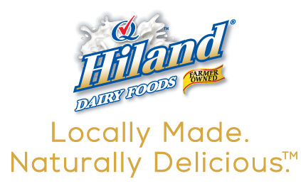

Contact: Kathy Broniecki, APR
Phone: 402 558-0637, ext. 107
Email: KathyB@envoyinc.com

FOR IMMEDIATE RELEASE

Chef Alli Wants To “Get You Cookin’!”
Hiland Dairy announces Chef Alli Appearances in Kansas City!

KANSAS CITY, Mo. August 16, 2019 -- Hiland Dairy has partnered with Kansas-based Chef Alli and will introduce her at two area events next week.

Cooking demonstrations with Chef Alli and tips for her delicious Instant Pot 5-Minute Pepperoni Pizza Pasta will be live at two area Hen House locations:
- Hen House at 6900 West 135th Street in Overland Park, Kansas on Friday, August 23 from 11:00 a.m. until 2:00 p.m.
- Hen House at 1721 Roe Avenue in Leawood, Kansas on Saturday, August 24 from 11:00 a.m. until 2:00 p.m.

Hiland Dairy will offer assistance with locally made, naturally delicious fresh milk and will have coupons and recipe cards for all that attend each event.

For nearly 20 years, Chef Alli has been stirring up a love of farm fresh cooking across her home state of Kansas. She has built a stellar reputation with her “Let's Get You Cookin' ” concept and it represents many things to its loyal followers: a source of culinary expertise, recipes designed to succeed, and encouragement from a trusted chef that makes every follower feel like a friend. Chef Alli's following has made her a sought-after spokesperson and speaker, as well as a food communicator who shares her personal story of agriculture to help other moms realize that they can trust the farmers and ranchers who raise our food.

Above all else, Chef Alli values her role as farm wife and mom; she and her husband, Pat, live in rural NE Kansas along with their three hungry sons where they raise cattle and enjoy all that country living has to offer.

“Real milk has always had a central focus in my life since I grew up on a farm and continue that lifestyle today along with my husband and sons,” said Chef Alli. She recalls making weekly trips with her Dad to the local dairy to get three-four gallons of milk in glass bottles. Chef Alli said that as kids, they would always try to make certain that at least one of those gallons was chocolate milk, which in her opinion was the best treat ever.

About Hiland Dairy Foods Company
Hiland Dairy, based in Springfield, Missouri, is a leading farmer-owned dairy foods company. Their widely loved products include ice cream, milk, butter, cheese and eggnog. Hiland Dairy has expanded beyond dairy and has a wide variety of other beverages, such as Red Diamond Tea, iced coffees, lemonade and fresh juices.

As a farmer-owned company, Hiland employs more than 2500 people across Arkansas, Kansas, Nebraska, Oklahoma and Texas. Hiland’s farmer-owners are just miles from the Hiland processing plants where our fresh milk goes from the farm to the shelves within 48 hours. This speedy process is environment-friendly and gives the signature fresh taste to all Hiland products! Hiland strongly believes in community and is committed to our environment. Using eco-friendly processes, Hiland continues to provide wholesome dairy to a healthy world.

Learn more at www.HilandDairy.com

